Appendix 4
Activities Report sheet and notes
Augusta Open Space
July 2015

1.Stories for the bees
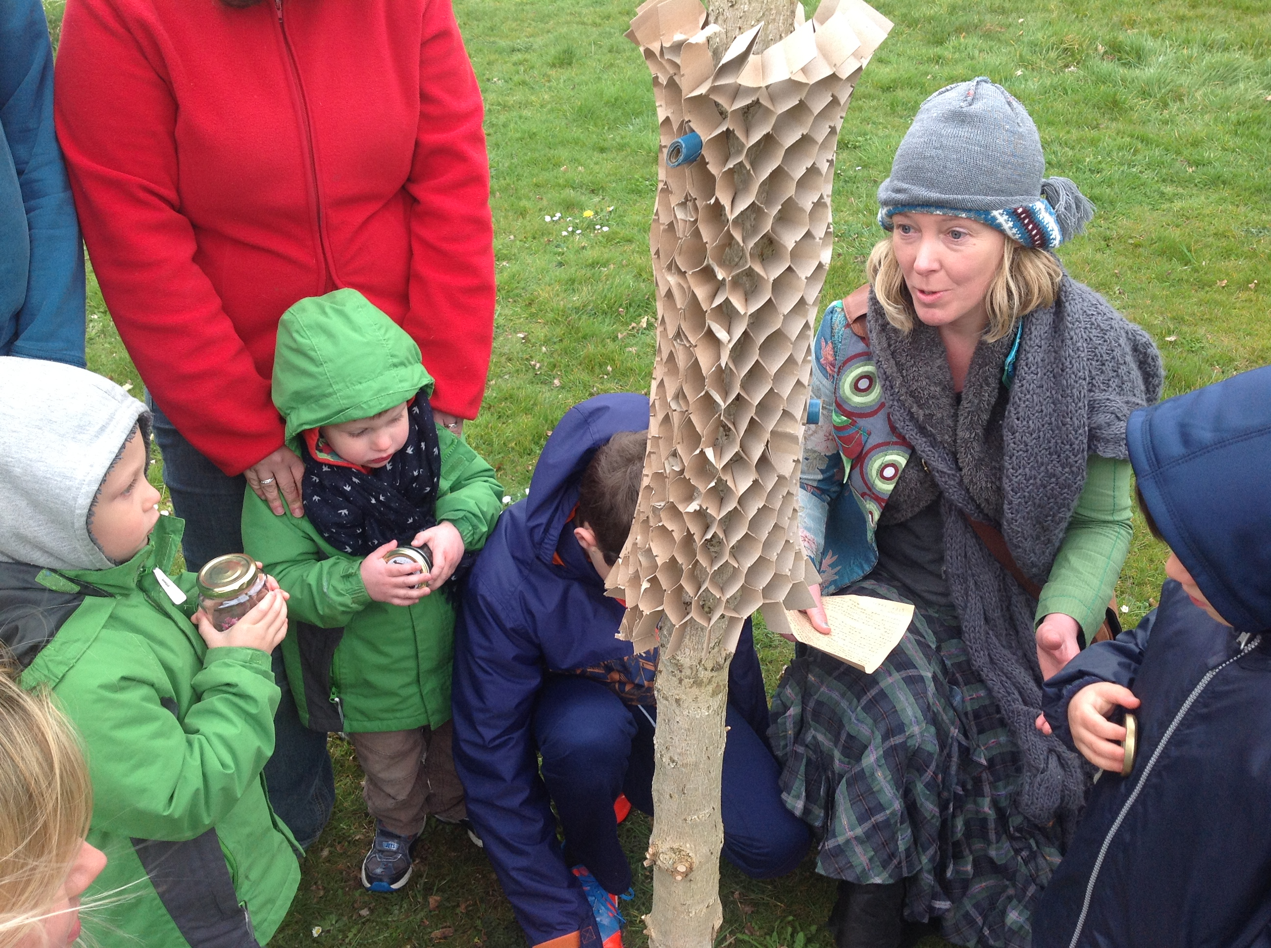

Date: 28th of March – 10.30 to 12.30
Advertising reach:
311 families via the school
800 Facebook reach from APCA
Posters at Community centre, school, Health centre

Attendance;
Adults 20
Children 17

Artists; Laurence Rushby, Judith Rodgers
Story teller; Samantha Holland

Activity presentation;
Stories for the bees

Stories are born from places and sites; a forest, a farm, a tree, a landmark.
Stories are about lives that have been lived and pathways that were walked on.
people create and tell the stories and the words are passed on.
The stories become part of the land, the place, the forest, the farm, the tree...

You are here, now and the story begins.
What do you see?
Who is with you ?
What catches your attention in the landscape, in the streets, in the people around you?
tell us where you walk, what you like here or around Augusta.

Let the bees guide your inspiration;

Pick up a word from each colour on the shelf to get your imagination going.
Follow Sam on a storytelling Trail and post your message to the bees.

Word for inspiration are out of Swinherd story and others.

Activity aims;

Create a sense of Place. Get people to realise and value what they have now. What is important to them and create memories with their families.

Expected outcome: Stories will mention places and values that are important to the residents.

Outcome;

The stories; the stories were written during the workshop, some by children and their parents, some by children alone, some by adults alone, inspired by the children around and the story teller.

“Augusta Park is a fanstastic place to live. Full of beautiful trees, barleyfields, poppy fields, dogs, playing fields and huge oak trees.”

“ The Old Oak tree I rest under, As the wind blows by, I curl up inside my comfy tent.”

“ We live on Augusta Park. I love my school. We want the open Space in commemoration of the armed forces. It is placed on Centurion Green.”

“ It is Saturday. I can see a dog. I can see my friend. I can see-hear my friend. I can hear cars going pass me- I can hear cars.”

“ Amelia and mummy went to the orchard. Amelia loves to blow bubbles into the wind with her friends. Amelia loves her doggys and Little Preston. Amelia loves to colour.” (Amelia and Mum)

“ Floors and the green. Heard you coming”

“ I like talking to mummy at the park. I say ; “I love you”.”

“I went for a walk with my family and friends. Luca picked me a flower and said; I love you”(Nicky Armstrong and Luca)

“ They did a competition to find the name for the green. We suggested Centurion because we are in the armed forces and we wanted to pick something that related to the history. We won. The green is now called Centurion Green.”
Fiona and family

“ I can see my nan’s house. I can see the park. That’s what I like”.
Ebony

“It all started with a chocolate face! That’s how the fun starts, very early On a Saturday morning! And before you know it, here we are in the windy green, (cold) park by the orchard. What about the chocolate face? Well he is running round and round the majestic oak tree and chasing a rather peculiar woodland fairy! What’s her secret? Lots of chocolate faces have gathered, how wonderful! She’s telling them a lovely story about the area, she’s clever too. She doesn’t even need a map! I do hope the chocolate faces enjoy being outdoor and will learn to protect their Augusta Park because it’s a great place to live, go to school, play, walk, observe nature and make new friends! PS; the chocolate faces are my favourite people in the universe! They are Maylis, Hayden, James, Sunny and Jeremy and all the other children… Oh the doggy came too! “

I am here with one of my mum’s friends and her daughter and son. I like the many huge fields where you can have walks with your dog and play football. I’m surrounded by majestic trees and growing little trees. The best times when you can enjoy your oak. Hear is when that bright golden coin went to light up the atmosphere of this wonderful place.”

2. Felted Animals workshop

18 March 2015
Held at Augustians weekly meeting
Based at Temporary Community Centre
Participants: 20

Introducing traditional woollen crafts in this workshop was a way to relate to the history of the place. It helped participants to understand the land through its materials and opened discussions on Possible artworks.
Most of the Augustians group members took part despite not feeling confident at first.
Made people feel relaxed about talking about art.

3. Precious Augusta

25th March 2015
Held at Augustians weekly meeting
Based at Temporary Community Centre
Participants: 20
What makes an object precious?

How do we select and define the importance of the object?

According to archeology principals, preciousness is defined by the percentage of Gold it contains.

The workshop at Augusta Park on March 25th was an opportunity to value and highlight what we have, today.

Gilding simple found objects, reflecting our current daily life, the landscape, and our history, we looked at how we can value simple things in order to grow relationships with the land, with the people around us and create the future of our community.

Precious Augusta became part of our Mini Museum collection on May 23rd.

The objects are part of the archives box at Test Valley Borough Council and could be exhibited at the new Community Centre or be placed in the Time Capsule.

4.Discussions
Total participants; 69(including walks and discussions at Community Centre)
a. Discussion; What is public Art?
We showed a series of artworks across the world to react on and comment;

Answers from group;
Should be Striking, make u feel good, can even be ugly but causes discussion,.
De sit speaks to me?

Fiona; The poppy fields stayed in my memory
Caused a reaction, attracted me and others
Became a meeting place
A memorial, something natural occurred! Everyone remembers them

1.Angel of North: Someone takes a flight, sense of freedom

Plain wings don’t match
Its big, protective

Discussion around the possible role of the art work as a protective figure for the community.

Spiral Jetty;
A road that goes nowhere: looks like a big cheese
A sense of purpose; you can walk on it!interactive

3. big ladies painted
looks like a disfigured clown face. Or 2 people cuddling, it gets people talking anyay.
Could be a waste of space: just wouldn’t fit in here.

Art has to be in the right place, the right setting

4.Bunny;
out of place
tacky
terrible
amusement park
fun
I love it!

5.Big mirror bum
huge sea mammal
with mirrors its got its own painting in it!

Don’t think people would like to see that here. It would clash. We need more natural materials.
But perhaps with the reflected image of the landscape it might blend in actually.

Playful, interactive with the landscape around

Impermanence;

I like the thought but I like something to go back to. To build up memories

Memories fade. Going back to a solid structure is a reminder.

Idea of a coliseum;
Could have a community place where you could run on summer fete.

Becomes a meeting point

b.Augusta Pie:
What do you bring to the table;

Attendance: 4
Already engaged; Carol, Brian, Lesley
Newly engaged from APCA and PTA at school;
Fiona Irwin

Fiona told about current project: Green Spaces, with APCA; fund received from Covenant to create sensory /memorial garden and some allotments dedicated to the community.(around £20000 project)

People brought a home made food item with written recipes to share with others. The recipes have become part of the book.

The attendants were offered to rename their dish with a Augusta word.

Discussion: We discussed the development of the project so far and how they had engaged to date.

We discussed life at Augusta;
“ Brian: “We call East Anton; that includes everything”
Divides between 3 different estates is too strong sand should not be.

Tree planting; I was involved in tee planting, we invited the children too telling them this is your wood”
A sense of the future; they need to understand responsibility.
We could look after the artwork
The trees taught them new skills.

Fiona; We live as an army family. We move around. To us it is important to have something permanent as our life is always changing. I want the children to build memories and be able to go back to view these memories later in life.

ROOTS are important; how about a living coliseum ? living willow?
I could look after it, I am a keen gardener! (rent a space scheme, the green space project with allotment and memorial garden)
Covenant fund

We have keen gardeners at Augusta Park!

A growing sculpture; with a sense of history themed shape
Would need to be tendered
Would create responsibility but would also grow with the children of the place.

Discussed ideas of creating a committee for the artwork: involved in decision making and commissioning. With representative of Augusta park residents.

Invite Jo Coomer , resident to join the committee(used to work for museum in London. Very knowledgeable on art) active member of the community, also set up the summer fete at Augusta
(Hugh her son was in the school workshops)

Events now are based on Centurion green
Last year moved to Old Smannelll road

I like the American artist who built things out of cardboard to host collection of things and set fire to it

Inside the community

The mural of Belfast: I find them really interesting: they tell the story as it was and how it should be even if it reminds fo dreadful things.
Its always going to be there.

6. Big dragon claw

Looks like a Disney movie.
It clashes with landscape natural;
Actually maybe its because of the colours that it blends in!

Themes important; History, history as it is now as well

Creating your own story is important.

An obvious core group is shaping as a possible committee for the artwork commissions.

The participants tonight have all been invited to attend a trip to Rochecourt art galleries as well as Mottisfont Abbey trip to view art on site for comments and ideas.

4. Walk and Talk;

As a way of reaching a wide range of people, we walked the estate and interviewed people in the parks, green spaces, door steps, outside schools…
We found this a more efficient way to reach people than the discussion events held at the Community Centre.

People reached: 60

Some of the notes taken during walks can be found here. Further notes are included in the archive box. All notes helped shape the final report. As well as asking a series of questions, we were showing images of public artworks around the world to trigger reactions.
The artwork shown can be found as a powerpoint presentation attached as appendix 5 and as printed photographs in the archive box.

Augusta Park Open Space
Field interviews 21/4/15
Part 1.
About Identity

-----------------------------------

Where do you come from?
Where were you before Augusta?

EC: From Stevenage, was living in Southampton wanted to get out of there. Met husband he is from Andover moved to AP

KD: Have travelled a lot as am in the military, most recently been in Germany for 3years. My children are in boarding school most of the time but have Toby the youngest at the moment here. There are 20 military houses on AP

Amanda: Bournemouth, liked it there, not like it so much here. Came to Andover 8 yrs ago and been 4 years on AP

Brenda K: Lived outside Newcastle in the middle of nowhere. It would be a 2 hour round trip to the cinema. Half an hour to the nearest shop. Moved here to help my daughter with her children

Alex Mc: Originally from Stonehaven in Scotland. Lived here 43yrs. I was in the military.

Steve: I am from Basingstoke, been here 3 days. We came here for the cheaper housing – am not sure what I think of AP so far.

What do you know about East Anton history?

EC: Getting to know it, but aware of some of it

KD: Recently arrived so beginning to find out, but I travel to the kids schools a lot so not much time to discover the history yet.

Alex: have seen so many changed it all was farmland, am v unhappy with the changes, all the wildlife has gone, I never see any deer or pheasants and lots of the birds have disappeared. They won’t return.

Can you imagine Augusta before it was built?

KD: Yes we imagine the farmland

Alex: I knew it before it was built, I am unhappy about AP, I did not want it here but who would listen to me?

What do you know about AP now? What’s going on etc

EC: My husbands parents live on Roman Way, we moved to the Chariots as not wanted to be in the main part of AP - the houses are too close and its as if people and houses are dumped there. The play areas are too busy and full, mostly we go dog walking with the kids.

KD: Find it v quiet, usually been in military quarters where there is an immediate friendly community for the kids and family. Found it harder to chat with people, although friendly they keep to themselves. It feels a bit remote, but it is early days to meet people but so far people seem more cautious than they are in other places I have lived.

Amanda: There is more going on here than Andover and much prefer it to Andover

Brenda K: I like AP, its friendly, there’s lots going on, its convenient we can just nip in the car to the shops and to town Its all easy to get to.

Alex: I am not involved with AP and don’t want to be

What do you bring to AP/share with others?

EC: I am community minded and want to get involved
KD: I would like to get involved in activities

Where do you go in AP/ favourite place?

KD: Love the feeling of space and peacefulness at the top near the pavilion. We use the playing areas as its less formal than the busy play park. The one near the community centre is too young and the skate park colonised by teenage older boys so not so inviting/safe. Hoping the new park will be fun. But prefer the open space. In Germany play areas are designed so that people have to move between play park slides and activities to promote greater interaction and walking to encourage healthy living and not just sit on a bench and watch their kids

EC: Near the playing fields and walks around there

Alex: I still like the dog walks but now some paths have gone and others created - I don’t know what is happening - it’s awful.

What makes you happy?
N/A

Part 2.
About Public Art

------------------------

Look around you, what would you like to see?

EC: I would like to see better use of the playing fields with benches and make better use of the space. Would like artwork to combine with history. Especially army history that is big in this area.

Alex: For the houses to go

Do you know any artwork? Which is your favourite and why?

EC: In Scotland we saw lots of public art, and particularly liked an installation of 20 dog bowls under decorated fountains. There were also recycling interactive arty activities that created dog treats for homeless/abandoned dogs. It felt fun and also useful

KD: I like artwork that you discover. That could be hidden in the trees. In Germany we visited parks where you discover the art, its a bit like geocaching and encourages people to see more of the area. It is a bit like looking for treasure where the art is dispersed about to find.

Alex: I saw a giant bicycle made from scrap – it was clever how it had been recycled

Look at examples and comment etc.

EC:
- Ok
- Interesting and seems more interactive
- Would be good if schools were involved – there are 3 schools in this area – I live next door to the headmaster of one of them and they would definitely get involved
- Like
- Like
- If it is to do with the area, I like that it is interactive. Would like something that changed with the season
- Yes If it was a relevant statement
- I think it would get vandalised. There is a younger generation on the estate that will wreck stuff
- No
- Yes, it’s emotive and has meaning. I like the idea of a seasonal piece of work that changes. Having a kids theme so that there is participation is important.
- Yes, though not sure what it is
- Yes, laughs
- Yes, I like the idea of giant insects - it would be different

KD:
- Like it but it’s a national statement, an artwork here is not about drawing people from outside in – it is for the community to enjoy here.
- Yes, I like work made from nature. I really liked up a Danebury Hill Fort and looking at the historical site there. What about the idea of a fake archaeology site – that would be really interesting.
- It would look good at a community centre, but could be time limited and look dated fast. The only people who like it are those that participated and then they grow up and it is not relevant so much. Maybe more of a temporary installation which pulls people in to participate
- Yes like – and finding them on a trail is great too
- Fun, but not related to community
- It would be good to have a blow up installation that could come out on community days or when there was a fete
- Unmoved by this
- It looks good but could easily be vandalised and is the sort of thing that gets appropriated by teenagers and excludes and intimidates others
- It is interesting, but too big for here and although I like it as an artwork it would not work here, as the AP artwork is not intended as an art visitor attraction.
- Very good – lots of overwhelming feelings with this work. It was good that it was temporary and did its jobs well: as it raised awareness and raised money. It was beneficial all round; attractive visually and raised funds.
- Yes, It is a national monument though, but animals always are liked and this artwork also has a stark message too and is emotive.
- Its fun, but could be too much of a statement and can date. Looks cool though
- Yes, like the idea of this being in a field and coming across it randomly.

From the stars pick the 3 most important

EC: History / Fun / Sensory (sensory especially important for teenagers)

KD: Community / Landscape / Unexpected
Toby (KD’son) Community / Interactive / Fun

Alex: Place/ Landscape / People

Steve: Striking / Good Community / Neighbours / Sensory

Kelly: Fun / Exciting / Interactive

Lynda: Striking / Community / Interactive

Amanda: Place / Community / Surprising

Sheila: Landscape / Community/ Fun

Brenda: Community / Fun/ Place

Where would you place it?

EC:
There needs to be a coming together across the estate as there is a risk of a divided community. Up at the pavilion is best. People spend time up near Harmony wood and the pavilion and have picnics. There are 3 schools close by that would get involved and visit the art.
Smannell area is close to town and lots going on already there with people travelling to Tescos and Dr’s. There is the skate park there and the new park. It’s a quick walk down there and don’t think art will be appreciated and it is more likely to be destroyed.
Its important to focus on the areas left. Also to attract the dog walkers so they don’t feel excluded

KD:
It would be good if the art was spread out, so it can be discovered. So it is in the Romans, Saxons and Chariots and there is a countryside trail of art.

Alex:
Up near the pavilion and near the woods. Be good if the work moved around and there were surprise ones with the trees – especially as they grow.

Lynda:
Old Smannell Rd

Amanda:
Fields where there isn’t anything

How would you like to be involved?

EC: Am interested to get involved and would come along to a meeting. Gave email.

KD: interested if time – gave email

Interviews with

Emily Collins – email: tara_babe6@yahoo.co.uk @ El Alamein footpath

Katie Davies and Toby – email – K8tdavies@yahoo.co.uk @ pavilion area

5. Treasure Hunt
Participation; over 68 people registered + unregistered

Time; over a months long

Aim: This is exciting High tech treasure hunt, using GPS, a phone and “Geocahe” (mini boxes hidden in the landscape containing clues) will attempt to retrace the ancient pathways. A sensory activity trail will insure access to all.
The Augustians and Crafty Chatters have created special objects to include in the boxes.
The aim is to invite people to engage with their place and imagine the site as well as make contact with the natural elements.

The treasure hunt attracted new participants to the project and new residents of the estate as a way to discover the place and engage with their community.
Collecting information from people happened mostly verbally when people were walking and hunting for treasures. The passports invited responses. Some passports were returned at the community centre. Many people preferred to keep them.
The treasure hunt was a great way to create a sense of space and participation to the project. It created connections between the people and the current landscape and the shaping of the estate.

It was more difficult to collect the expected information than first anticipated but the feedback, as an overall project was great. It also introduced the idea of having a trail rather than a fixed artwork. The people considered the treasure hunt itself as an artwork/art event.

It also highlighted places of importance on the estate.

6. Iron Age Museum visit
Attendance: 10

Augustian Group

The group enjoyed their visit and gained the ability to visualise their history research carried for the history box.
The visit highlighted the different parts of history that are related to the estate. They were able to handle objects and view shapes that inspired their responses and ideas during discussions.

8. Mini Museum;
Participants; 48

What is Augusta? Who lives here? What makes it special?

Augusta Open Space has been with you for the past 3 months. Through many activities, you have met the people of Augusta, played with art and history during a treasure hunt or discussed public art. It all came together on the 23rd of May on Smannell Green

The mini museum was set within the newly acquired TVAF art bus; the bus is a former library bus, which is in the process of being transformed into a moveable art workshop/gallery across the county. The day was filled with activities, conversations, and exhibitions of school children’s work, re-enactor, art workshops, story telling and more.

The day offered another opportunity for the public to visualise the achievements of the project and add to the conversation.
It also highlighted the site of Old Smannell road as a potential space for an artwork.

9. Augusta on the Road

A visit to Mottisfont abbey was designed to prepare the Art committee; 9 people joined in.
The event generated further discussions on the shape of the artwork and its relation to historical context .

7. Email feedback from some participants;

Jo Coomer; Mini Museum ideas
25.05.15

This looks great Laurence! Love it!

Thinking of notions of collecting, cabinets of curiosity, categorisation - representations of museums - some kind of Augustian database or museum against grouping, developments like the original attempts to classify the natural and built world according to a burgeoning evolutionary development versus the marvelous, freak, unique new discoveries, and the historical world - antiquities, ancient remains, fossils, which were being shared eg. by Cassiano dal Pozzo, a living breathing map of a live community mapping against a transient changing historical and built environment and the idea of memory and precious captured recordings.

A guy called Job Koelewijn did Kids Walk Away with my Thoughts - notes, poems, stories recorded during a specific period got folded into paper hats and handed out to the children and they were photographed walking around the school wearing them, in a Primary school in Spakenburg in 1993.

I feel really strongly about the children's experiences and memories of watching the estate being built, moving in and creating the community through their routes of play, walking to school, meeting up on scooters and bikes, and doing your geo cache trail and the treasure hunts that the community center did, organised at their events and fairs - and what the real treasure is going to be as they grow and the community grows and changes and the shared networks and routes through life this will create.

Feed Back email
Fiona Irwin
29.04.15

Hi Laurence, thank you so much for organising last nights event. I thought it was brilliant. It was so nice to see other enthusiastic people.
I spoke with Jo Coomer this morning on the school run and she would love to come along to the gallery trip, if that is possible. She has so many ideas and really is a little gem of knowledge. She was keen for me to give you her details. She knew straight away the name of the gallery in winterslow and the lady who manages mottisfont abbey was a year above her in university. Jo is great, she is so interesting and passionate about art . Jo's email address is
Jo.coomer@btconnect.com
Thank you so much for my piece of art, I absolutely love it. Plus it's a little bit of Molly’s birth place to take with us wherever we go
Thanks again

