The Lost Bush

By Samantha Holland

Created for Augusta Open Space

May 2015
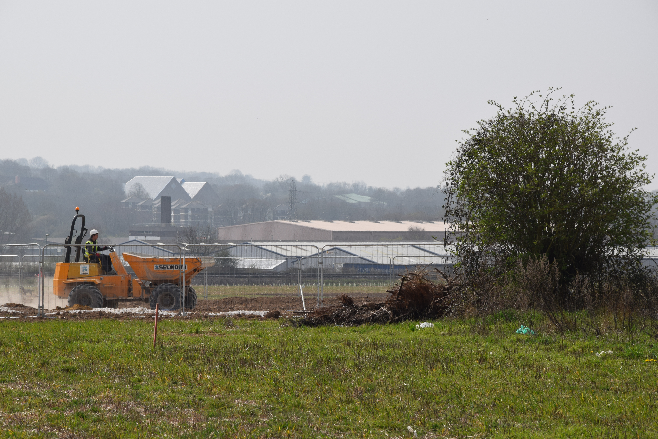

The row of trees marking the boundary of the land on the southern edge of Augusta Park had seen many changes in the landscape over many years.

The houses had sprung up and the community had grown, changing the shape of the fields and contours of the hills.

The trees that marked the boundary knew that a day would come when one of them would be chosen as a keeper of the line between the new bricks and mortar and the fields that stretched beyond. They also knew that the rest of them would go.
So a conversation started between the trees as to who was the most important.

The conversation became a discussion.
The discussion became an argument between the biggest and most self important of the trees and all the while, the littlest tree (who was considered more as a bush than the tree by the others) stayed quiet.

The bigger trees laughed at the little tree, saying that he would be the first to go when the time came.

Sure enough, the men and women with hard hats and reflective jackets arrived at the boundary line to probe the ground and measure the trees.

Sure enough, one by one the diggers came, & one by one the trees were dug out of the ground and taken away for firewood.

Until only one tree remained; the little tree, that the bigger trees teased, the last bush (or as she is now known:” The Lost Bush”) asked the man why she had been saved, over the bigger, more important trees.

The man with the hard hat smiled and spoke gently to the little tree;
“ You appear small on the surface, but I can see that a greater part of you stretches out far across Augusta Park; your great roots hold the landscape together and without you, the earth would crumble and fall. I saved you so that the community that grows here will be safe in your hidden embrace.

To be continued…

